ARTICLE 14-6
DESIGN STANDARDS

Section 14-6-1 Purpose

- The purpose of this Article of the Subdivision Ordinance is to provide the development community and the citizens of Maricopa with a minimum set of standards to guide the physical development and the visual quality of the subdivisions being developed throughout the community. The design standards in this article apply to all developments in the City. The intent is to create functional, attractive developments, to help preserve the natural beauty of the City by preserving open space, minimize adverse impacts on the community, and to insure ensure that future subdivisions will conform to the community’s expectations while at the same time encouraging new development that is dynamic, creative and imaginative.

Section 14-6-2 General Provisions

- Every subdivision shall conform to the Maricopa Zoning Ordinance Code, the Maricopa Design Standards Manual, other ordinances and regulations of the City, and the Arizona Revised Statutes, as well as implement the goals, objectives, and policies of the Maricopa General Plan. In the event two or more requirements conflict, the most restrictive requirement shall apply.

- All public improvements shown on the preliminary plat, and any additional improvements that may be required by the Commission as a condition for approval of the preliminary plat shall be the responsibility of the developer. All public improvements shown on the final plat and the improvement plans, and any additional improvements that may be required by the City Council as a condition for approval of the final plat, shall be the responsibility of the developer.

- All improvements must be acceptable to the Zoning Administrator prior to the issuance of building permits for lots within the subdivision. Building permits for model homes, sales offices and construction site trailers may be allowed, prior to the acceptance of the subdivision improvements by the City, with a Temporary Use Permit (TUP) issued by the City, along with the written approvals of the Maricopa Fire District Department, water, electric, sewer and other affected utility providers.

- Where the area proposed for development contains all or part of a park, a trail and/or a trailhead, a school, flood control facility, or other public site, as shown on the General Plan or as recommended by the Commission or City Council, such site shall either be dedicated to the public or reserved for acquisition by the public or appropriate agency or land trust within a specified period of time as prescribed in A.R.S. 9-463.01 (D) and (E).

- Land which is subject to periodic flooding, land which cannot be properly drained, land which has unstable soils or slopes (fissures), or land which is otherwise unsuitable for residential or commercial uses shall not be subdivided; except that the City Council may approve the subdivision of such land upon receipt of evidence, including subdivision construction assurances, satisfactory to the City Engineer and City Attorney that the construction of specific improvements will render the land suitable. The construction of subdivision improvements shall not commence until after final plat approval and financial assurances have been secured to the satisfaction of the City Engineer, Zoning Administrator, and City Attorney.

- All utilities listed on Final Plat shall be operational prior to granting any “Certificate of Occupancy”.

Section 14-6-3 General Site Design Standards

- Regardless of the density of the individual developments, single family residential subdivisions, and condominium or multi-family subdivisions shall be required to provide the following: open space, buffering to adjacent developments, landscaping, and physical connections to adjacent neighborhoods and to the community open space network and/or the City of Maricopa’s green belt and urban trail system.

- Commercial and industrial subdivisions shall be subject to all the requirements set forth in the Zoning Ordinance and shall be designed according to the same principles governing the design of residential developments; namely, buildings shall be located according to topography; factors such as drainage, noise, odor, and surrounding land uses considered in sighting buildings; sufficient access shall be provided; adverse impacts buffered; and landscaping provided. In addition, the following standards shall apply to commercial and industrial subdivisions:

      - Commercial and industrial lots/developments that back up to an existing or designated residential land use shall provide a landscaped open space buffer strip adjacent to the common property line to allow for a trail system and to mitigate any adverse affects effects to the residential neighborhood from a permitted commercial or industrial use. The required buffer strip shall be a minimum width of twenty-five (25) feet for commercial lots/developments and forty (40) feet for industrial lots/developments. This buffer area is not to be used for parking, service drives, or storage and perimeter fencing of the commercial or industrial lots/developments shall not be allowed within the buffer strip.

      - The Planning and Zoning Commission and the City Council may impose special requirements with respect to the design, construction and installation of the public utilities, street, curb, gutter and sidewalk.

- Those portions of the community open space network adjacent to, or within, the area proposed for development, whether residential, commercial, or industrial shall be incorporated by that development. Construction of the open spaces, trails, and trail amenities shall be the responsibility of the developer and shall be part of the subdivision improvements. These trails shall be part of a “tract” and maintained by a Homeowners/Property Owners Association unless the open space and/or trail has been accepted, by the City of Maricopa, into the City park system for maintenance responsibilities. Dedication of a trail and/or trailhead to a local land trust, established for the purpose of trail development and maintenance, may also be acceptable.

- When the intersection between a multi-use trail and an arterial and/or collector roadway is unavoidable the roadway shall be designed with a center median at the location where the trail intersects the roadway so that the trail users are protected from a potential conflict with the vehicular traffic. The minimum dimensions of these center medians will depend upon the type of multi-use trail that the road bisects (see Figure 1 and Figure 2). Alternative methods may be considered if approved by the City Engineer.

- Tracts or parcels of land proposed for subdivision development that are adjacent to an Indian Reservation shall provide an adequate buffer to the Indian Community.

Section 14-6-4 Open Space and Recreation Requirements

- General Open Space Requirements - The purpose of these open space regulations is to provide for open space, recreational, and alternative transportation opportunities and trails within each subdivision and connectivity to the greater community.

- Open space intended to fulfill these open space requirements shall be calculated upon the net acres of the subdivision whether residential, commercial, or industrial. Net acres for a residential project are defined as: total acres exclusive of the area required for arterial or collector street right-of-way dedications, reserved school sites, multi-family parcels, and all commercial and/or industrial acreage. Net acres for nonresidential projects are defined as: total acres exclusive of the area required for arterial or collector street right-of-way dedications. Required open space for all types of subdivisions shall be as prescribed in the following Table 2 or per the Council approved M.P.D. or P.A.D.

- The development, through the Planned Area Development (P.A.D.) process as described in the City of Maricopa Zoning Ordinance, upon the requisite findings, may vary the minimum lot area and minimum lot width from the standards specified in the zoning district(s), in effect over the area considered for subdivision, provided that such variations are approved by the City Council prior to or in conjunction with, the preliminary plat approval for the subdivision. Every P.A.D. shall provide open space in accordance with Table 1 in Article 14-5 and/or as approved by the City of Maricopa through the PAD review process.

- The development, through the Master Plan Development (M.P.D.) process as described in the City of Maricopa Zoning Ordinance, shall provide open space in accordance with Table 1 in Article 14-5 and/or as approved by the City of Maricopa through the M.P.D. review process. The design of the open space shall be integrated throughout the development and connect the development to adjacent developments and the community in general.

- Residential developments, excluding multi-family residential developments, shall be responsible for developing seven (7) acres of Neighborhood/Subdivision Parks per 325 lots. These parks will be calculated as part of the required open space and should be maintained by the Homeowners Association (HOA) except when the parks have been accepted into the City Park System for maintenance responsibilities, by the City of Maricopa.

Table 2 - Open Space Requirements
TYPE OF DEVELOPMENT | REQUIRED PERCENTAGE  OF OPEN SPACE
Rural Residential | 0% (1 - 49 lots in size)  2% (50 or more lots)
Estate Residential | 0% (1 - 49 lots in size)  2% (50 or more lots)
Low Density Residential | 0% (1 - 49 lots; min. lot size 54,000 sq. ft.)  2% (50 + lots; min. lot size 54,000 sq. ft.)  10% (1 - 49 lots; min. lot size 20,000 sq. ft.)  12% (50 + lots; min. lot size 20,000 sq. ft.)
Medium Density Residential | 15% (1 - 99 lots; min lot size 12,000 sq. ft.)  17% (100 + lots; min lot size 12,000 sq. ft.)  20% (1 - 99 lots; min lot size 7,000 sq. ft)  22% (100 + lots; min lot size 7,000 sq. ft)
High Density Residential ⁽¹⁾ | 20% for detached products  100% of the 1st floor total floor area &  50% of the 3rd floor total floor area ⁽¹⁾
Master Plan Development (M.P.D.)  Planned Area Development (P.A.D.) | Per Table 1 in Article 14-5
Mixed Use Development | 15%
Commercial Development | 10% (20 acres or less in size)  15% (greater than 20 acres in size)
Industrial Development | 10% (100 acres or less in size)  15% (greater than 100 acres in size)
(1) If a High Density Residential development is part of a M.P.D. then the 3rd floor total floor area open space requirement is not required.

- Those portions of the Maricopa Urban Trail System, as identified in the General Plan for the City of Maricopa or updated Plan Elements, that are adjacent to, or within, the area proposed for development shall be incorporated by that development. Construction of those portions of the trail corridors shall be the responsibility of the developer and shall be part of the subdivision improvements. Certain portions of the Maricopa Urban Trail System, more specifically the Santa Rosa Wash and the Santa Cruz Wash, shall be dedicated to the public upon completion of the improvements or as agreed upon by the City. Public access easements shall be required to provide access to the Maricopa Urban Trail System from public parks and open spaces and, where appropriate, from the private parks within the residential developments when adjacent to the Maricopa Urban Trail System.

- Open space, in general, may also include any parking area landscaping that exceeds that which is required by the Zoning Ordinance. Open space does not include parking areas except parking lots for trail heads and/or for the neighborhood parks (not parking lots required for other uses). Bicycle trails (not bike lanes within the pavement section), pedestrian trails (not sidewalks integrated with the curb), equestrian tracts, and trail heads may also be calculated as open space. Landscape buffers and landscaped medians shall be a minimum of fifteen (15) feet in width in order to be calculated as part of the required open space. Open space does not include retention and/or detention basins that are concrete lined or non-landscaped, vacant lots, or undeveloped lots

- Open Space Design Standards

    - Neighborhood parks and those portions of an individual development’s open space system should be developed adjacent to the Maricopa Urban Trail System, whenever possible, to provide linkages to the greater community. Construction of the development’s neighborhood parks and/or the open space areas shall be the responsibility of the developer and shall be part of the subdivision improvements. The open space areas within an individual development shall be part of a “tract” and maintained by a Homeowners/Property Owners Association unless otherwise approved by the City of Maricopa.

    - At a minimum sixty percent (60%) of the required open space for any development should be developed as “useable” open space with the recreational amenities needed to support the new neighborhood demand incorporated into that open space.

    - The open space areas shall be designed in such a manner as to be easily accessible to all lots. Accessible means that there is no more than 1/6 of a mile or 880 feet of pedestrian travel between any one lot and an entrance area allowing wildlife corridors, people, bikes or equestrians to enter into the open space area or view the open space area.

    - Retention or detention basins, which are required in accordance with the subdivision drainage report, shall qualify as open space only if they are landscaped, multi-tiered and designed to be used as an active multi-use area. Retention basins with a bottom area in excess of one half (1/2) acre, shall be designed, turfed and equipped to accommodate a play/sport field rather then being landscaped with decomposed granite. All recreational facilities, tot lots, play equipment, and amenities within the basin shall be located at least one (1) foot above the 50-year storm level, 2-hour storm level. The exception to this standard is for commercial and industrial developments, which shall be permitted to calculate the landscaped retention or detention area as part of the required open space area. Terracing, berming and contouring may be required to naturalize and enhance the aesthetics of the basin. Basin slopes shall not exceed a three four to one (3:1) (4:1) slope.

    - All retention basins shall be designed to drain within thirty-six (36) hours of a major storm event.

    - Existing watercourses or drainage ways shall qualify as open space if they are incorporated into the design of the subdivision in their historic (unaltered) location, given a “natural” character (not ditch-like in design), constructed with/of natural materials, and incorporated into the larger open space design.

    - Not more than fifty percent (50%) of the required open space shall be attributed to golf course use or ancillary golf uses.

    - If the developer chooses to provide a detached curb separated sidewalk with a tree-lined street cross section, as the local street cross section, the “boulevard landscape strip” area, inclusive of that portion of the public right-of-way starting from the back of curb and including any easement specifically granted for landscaping or pedestrian purposes, shall be a minimum of fifteen (15) feet in order to be calculated as part of the required open space.

- Multi-Use Trails and Trail Requirements

  - New developments shall incorporate, at a minimum, and where appropriate, multi-use trails as an integral component of the required open space of the developments. These trails must be located and designed to assure complete separation from vehicular traffic. Trails shall have an average minimum separation of five (5) feet from the back of curb to where the trail is when adjacent to and parallel with a street.

  - Multi-use trails shall be used to interconnect the various parks and tot lots of a development, the various neighborhoods of a larger development to each other, and the overall development to the Maricopa Urban Trail System. Particular care should be given to linkages with adjacent subdivisions within a larger development to promote internal pedestrian and bicycle traffic without crossing arterial or collector streets as much as possible. Signs, crossings, vegetation, rest and staging areas, and surface materials shall be developed, designed, and installed in conjunction with the development and in a manner appropriate to the specific users intended.

  - Pedestrian, bicycle and equestrian trails within and through a development shall connect to and be a part of the open space system of the neighborhoods and the City. These trails should be landscaped and minimally furnished to provide shade and rest areas in order to encourage their extensive use as a secondary mode of transportation, recreation, and access throughout the neighborhoods and the City.

  - Multi-use trails shall have a total right-of-way or easement width of not less than twenty (20) feet to accommodate landscaping and furnishings as well as a thirteen (13) foot wide path that is a combination of a nine (9) foot hard surface constructed of either concrete or an all-weather surface such as rubberized asphalt, or similar material and four (4) foot of decomposed granite (see Figure 1). If the multi-use trails include an equestrian trail the total right-of-way or easement width should be not less than twenty-five (25) feet with the additional twelve (12) foot portion devoted to equestrians constructed of a softer-surface treatment consisting of finely ground gravel or other compatible dense, yet soft material; but not cinders (see Figure 2).

  - When approved, unpaved trails shall be designated for limited and specific uses rather than for general use. The design and construction of these unpaved trails shall be in accordance with, and appropriate to, the specific uses allowed. Unpaved trails may also be within or over local utility easements/corridors in order to allow utility access while achieving neighborhood connectivity.

  - Those portions of the Santa Rosa Wash and the Santa Cruz Wash that are required, per the FEMA plan, to be retained as non-buildable for flood plain purposes shall be dedicated to the public by the adjacent development and constructed in accordance with the City approved open space and recreation plans by the developer. Trails within the Maricopa Urban Trail System associated with the Santa Rosa Wash and the Santa Cruz Wash shall be constructed in conjunction with the adjacent developments and credited towards the open space requirements (see Figure 3).

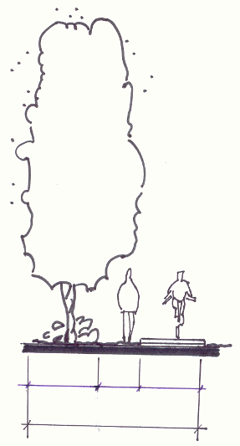
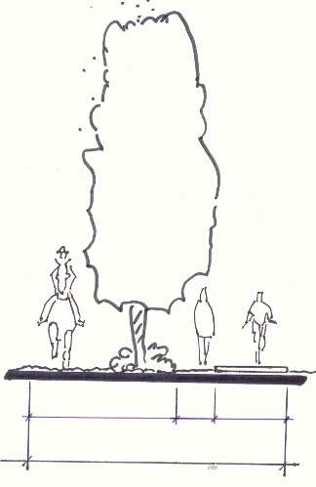
Figure No. 1
Multi-Use Trail
20’ min width
9’
4’
7’
Figure No. 2
Multi-Use Trail with an Equestrian Trail
9’
4’
25’ min width
12’

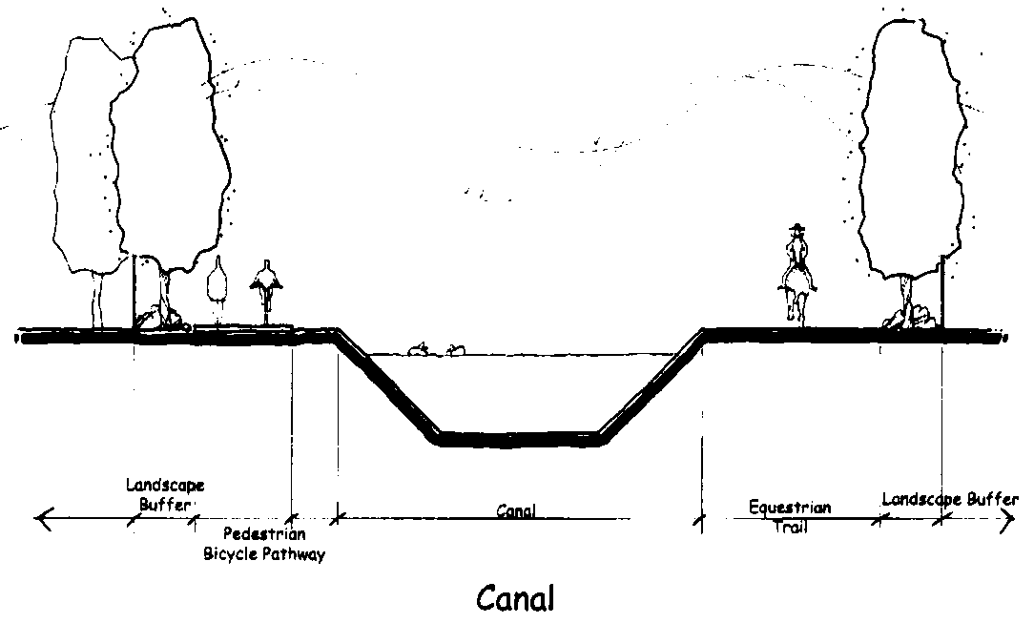
Figure No.3
Flood Control Canal/Maricopa Urban Trail

- Recreation and Tot Lot Design Requirements

- All tot lots Tot Lots incorporated into Open Space must be covered with a shade structure over the play equipment. All Tot Lots and play structures shall be designed to be located at least one (1) foot above the 50-year, 2-hour storm level if located within a retention or detention area.

- Tot Lot playground surfaces must consist of sand and/or a rubberized material, commonly referred to as “tot turf”, or other resilient surface, in the designated fall zones as designated in or by the playground equipment manufacture’s specifications.

- Wood chips Sand shall not be a permitted material for use within the Tot Lot area.

- All grass installed in a development for general landscape use and for open space must be hypo-allergenic (midiron) sod or stollons (no seed).

- Outdoor lighting, in conformance with the standards outlined in Sec.14-6-16 of this ordinance, shall be required at both the tot lot Tot Lot and the Ramada area, as approved by the Zoning Administrator.

- A Ramada within the Open Space areas must be constructed with stone columns or other durable material of equal quality, as approved by the Zoning Administrator, and a solid roof structure, such as but not limited to, standing seam metal, corrugated metal, concrete tile, clay tile or similar roof material. The Ramada must also include a BBQ grill, a minimum of two (2) tables, two (2) trash cans, and one (1) bike rack.

- The location of neighborhood parks, mini parks, Tot Lots and similar recreation areas should wherever possible be internalized to the neighborhood and not adjacent to an arterial street or a body of water. If, however, a Tot Lot is placed adjacent to an arterial street or a body of water, it must be buffered with a wall constructed of stone or other durable material of equal quality, as approved by the Zoning Administrator, that is set-back at least ten (10) feet from the sidewalk and twenty (20) feet from a body of water.

Section 14-6-5 Landscape Requirements

- General Requirements - When different land uses are adjacent to each other, landscaping is one (1) method of minimizing the impact and establishing a transition between them. Plant materials can filter air, curtail erosion, provide shade and maintain privacy.

- Healthy significant existing trees located outside of the proposed roadway pavement, within retention/detention basins, adjacent to a pre-existing watercourse, or within the proposed subdivision open space areas shall be preserved in accordance with the approved landscape plan.

- Landscape plant materials, in addition to the healthy cacti and trees retained on-site, should consist of drought tolerant indigenous plant materials and species listed in the landscape regulations of the Maricopa Zoning Ordinance and Appendix A of this Ordinance.

- Replacement of dead trees and required landscaping shall be by the Homeowner’s/Property Owner’s Association or the individual property owner and shall be completed within three (3) months from the date that the Association or the property owner is notified by the City.

- Plant Specifications

General – A drip irrigation system shall be installed by approved standards to provide for the long term health and maintenance of the required landscape.

Trees - Where required by this Ordinance shall be, upon installation, a minimum of two (2) inch caliper in size or fifteen (15) gallon size, whichever is larger. Sixty (60%) percent of the required number of trees shall be specimen trees of twenty-four (24) inch box size or larger.

Shrubs - Where required by this Ordinance shall be, upon installation, a minimum of one (1) gallon size with fifty (50%) percent of the required number being five (5) gallon in size.

Organic Groundcovers - Where required by this Ordinance shall be a minimum of one (1) gallon size upon installation. Turf may also be considered for use in small select areas and must be hypoallergenic (midiron) grass.

Inorganic Groundcovers - Where required by this Ordinance shall be used and consist of decomposed granite (minimum size ½ minus). River rock, or pea gravel, in selected areas, may also be considered.

- To insure ensure plant materials are installed and properly maintained, a Preliminary Landscape, Recreation and Open Space Plan will be required of all developments as part of the Preliminary Plat submittal package and a Final Landscape, Recreation and Open Space Plan as part of the Improvement Plan submittal package (See Sec. 14-7-3 (C) for details). This plan shall show all required plant materials location, include a plant list/palette, indicate species, size, quantity, and spacing specifications. Irrigation plans shall be included with the landscape plans.

- Street Tree/Streetscape Requirements - Streets are the true public realm which are experienced by everyone and provide the most visual sense of the overall look and feel of a community. Landscaping is a major element of the streetscape.

1. Arterial and Collector Streets

    - A minimum of one (1) tree and three (3) shrubs and/or organic groundcover per tree shall be planted every thirty feet (30’), or fraction thereof, in such a manner as to create the appearance of a tree lined street; exclusive of that portion of the public right-of-way occupied by a driveway area. These trees should, however, be spaced according to each species’ needs. Additional streetscape such as, but not limited to, benches, school bus stops, trash containers and multi-use trails may be required.

    - Individual property owners and/or Homeowner Associations shall properly maintain all landscape materials and landscaped areas, including that within the public rights-of-way adjacent to the development, in accordance with the approved landscape plan, except in and along public rights-of-way and easements where the City of Maricopa has agreed to provide maintenance.

    - Replacement of dead trees along arterial and collector streets shall be by the individual property owners or the Homeowner’s Association and shall be completed within three (3) months from the date that the Association or property owner is notified by the City.

2. Local and Neighborhood Streets

- For all PAD and conventional subdivisions (individual lot) the landscape plan shall include, at a minimum, two (2) canopy-type shade trees of fifteen (15) gallon size or greater for each lot. For multi-residence subdivisions (attached product, condominiums, townhouses, etc.) the landscape plan shall include, at a minimum, one (1) canopy-type shade tree of fifteen (15) gallon size or greater per dwelling unit. These shade trees shall be placed either within a front yard landscape easement or within the right-of-way between the back of curb and the sidewalk.

- In areas not associated with a lot, a minimum of one (1) tree shall be planted every twenty-five (25) feet, or fraction thereof, depending on the recommended spacing according to each species’ needs. The trees shall be planted in either a landscape easement or within the right-of-way. The location of the tree shall be between the back of curb and the sidewalk or trail, where a sidewalk or trail are required, in a lineal pattern creating a tree lined street.

- Commercial and industrial subdivisions shall provide a minimum of one (1) tree and three (3) shrubs and/or organic groundcover for every thirty (30) lineal foot of street frontage or fraction thereof; exclusive of that portion of the public rights-of-way occupied by a driveway area.

- Individual property owners, and/or Homeowner Associations, and/or Property Owner’s Association shall properly maintain all landscape materials and landscaped areas, including that within the public rights-of-way adjacent to the development, in accordance with the approved landscape plan, except in and along public rights-of-way and easements where the City of Maricopa has agreed to provide maintenance

- Development Landscape Requirements - Streets comprise approximately twenty (20%) percent of the overall development. The remaining land is devoted to the individual lots, the required open space, and the retention or detention basins. The landscaping of these areas is equally important to everyone as it provides a visual sense of the community and is a quality of life element.

  - Single Residence Developments

    - All developments shall provide landscaping within, but not limited to, the adjacent public right-of-ways as indicated in Sec 14-6-5 (B), required open space areas, retention or detention basins, and the community trail system if applicable.

    - The front-yard landscaping is required to be installed, at the time and as a part of, the home construction. For “tract home” or “standard plan” subdivisions the front-yard landscape packages must be submitted with the “home product plans review” submittals. For custom home subdivisions the landscape plans for the individual lots may be delayed until the individual house plans are submitted.

    - The use of turf may be considered, within the front yard landscape, provided the total area of turf does not exceed fifteen (15%) percent of the total front yard area.

    - The required landscaping for a development shall be installed in proportion to the construction phasing of the project and in accordance with the approved subdivision landscape plan.

  - Multiple Residence Developments

- All developments shall provide landscaping within, but not limited to, the required open space areas, retention or detention basins, the community trail system if applicable, parking areas, buffer areas and the adjacent public right-of-ways as indicated in Sec 14-6-5 (B). Installation of the required landscaping shall be in accordance with the approved landscape plan for the development.

- All developments shall provide a minimum of one (1) tree and two (2) shrubs per dwelling unit in the common area open space.

- The required rear and side yards shall contain a continuous landscaped buffer area having a minimum width of ten (10) feet and containing a minimum of one (1) tree and two (2) shrubs every twenty-five (25) feet, or portion thereof, to provide visual screening between adjacent uses.

- A landscaped buffer area a minimum width of fifteen (15) feet and not exceeding a three to one (3:1) slope shall be provided and maintained by the multiple residence development along the common property line when abutting a property zoned as single residence or abutting the community trail system as indicated in the Maricopa General Plan.

  - Commercial and Industrial Developments

- The required landscaping for a development shall include the required open space area, retention or detention basins, the community trail system if applicable, parking area, buffer areas, and the adjacent public right-of-way as indicated in Sec 14-6-5 (B). Installation of the required landscaping shall be in accordance with the approved landscape plan for the development.

- A landscaped buffer area with a minimum width of twenty-five (25) feet for commercial and forty (40) feet for industrial and not exceeding a three to one (3:1) slope shall be provided and maintained by all commercial and industrial developments along the common property line when abutting property zoned as single residence, multiple residence or the community trail system and open space areas as indicated in the Maricopa General Plan.

- Landscaping, combined with architectural treatments, shall be provided to completely screen unattractive views and features such as storage areas, trash enclosures, railroad sidings and yards, transformers, generators, heavy mechanical equipment and other similar eyesores.

- Neighborhood (Subdivision) Entry Monuments - In order to enhance the appearance and help identify subdivision entrances, developers are encouraged to provide landscaping, identification signage and textured pavement at the entryways on at least one major access point to the subdivision.

- Landscaping at entryways should be designed to visually enhance all arrival points. Clustering of trees, shrubs, and ground covers should accent focal points and provide variety to streetscape. Trees along the streets shall consist of drought tolerant indigenous plant materials and species listed in the landscape regulations of the Maricopa Zoning Ordinance and Appendix A of this Ordinance.

2. Signage shall be attractively designed and submitted along with the required landscape plans for approval. Signs shall be integrated to complement the streetscape and landscaping frontages using a decorative monument base. Monument signs shall not exceed those allowed and outlined in the Maricopa Zoning Ordinance.

3. Textured entryway drives (such as decorative stone, stamped concrete or brick) may be incorporated into access points from any collector or arterial frontages.

- Wall/Fencing Requirements - In order to enhance the appearance of the community, neighborhoods rather than individual subdivisions are desired. “Walled-in” separated subdivisions do not create neighborhoods by themselves and are strongly discouraged.

  - Single and Multiple Residential Standards:

- The use of solid view-obscuring perimeter walls along the boundary of the subdivision is not permitted except where specifically indicated on the final plat and approved by the City Council. Perimeter walls adjacent to the community open space system shall be view-fences. External orientation of the subdivision to the surrounding arterial, collector and local streets (depending on the project density) as well as adjacent residential development is strongly encouraged and should limit the need for solid view-obscuring perimeter walls.

- Openings in the perimeter view-fence are encouraged at the end of abutting interior cul-de-sac streets and along the community trail system, if applicable, to provide the desired connectivity to the community.

Figure No 4 - Residential View Walls and Fences (illustrative only)
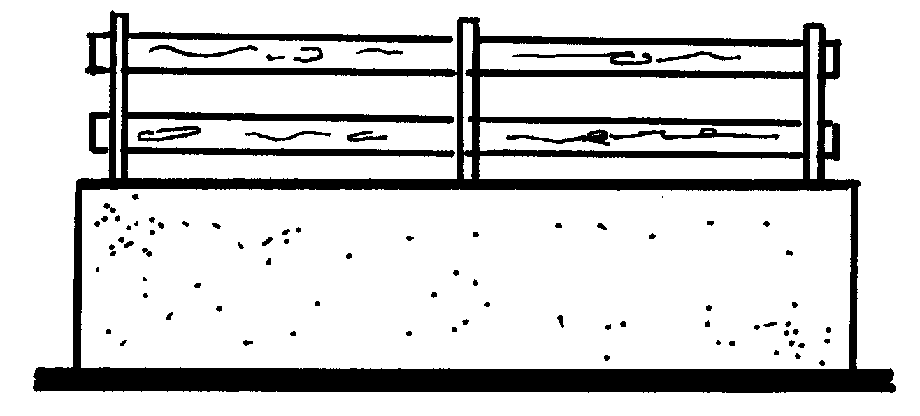
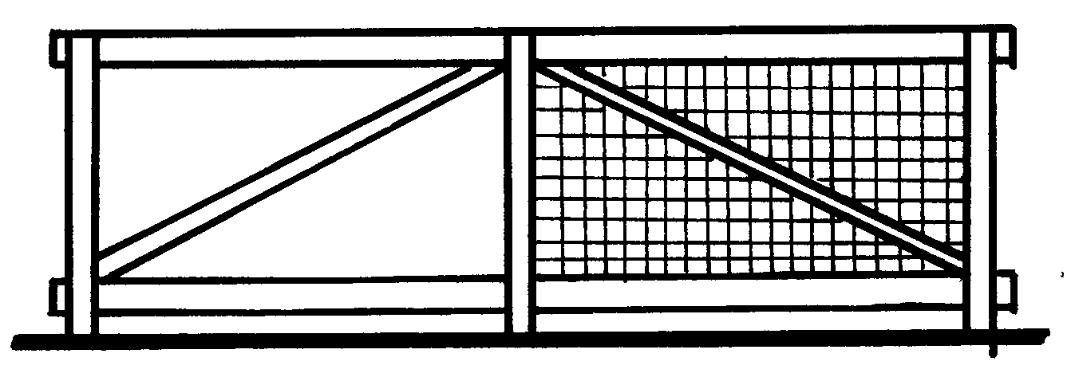
Solid wall and corral fencing combination.
Pipe rail or corral fencing with wire mesh or chain link

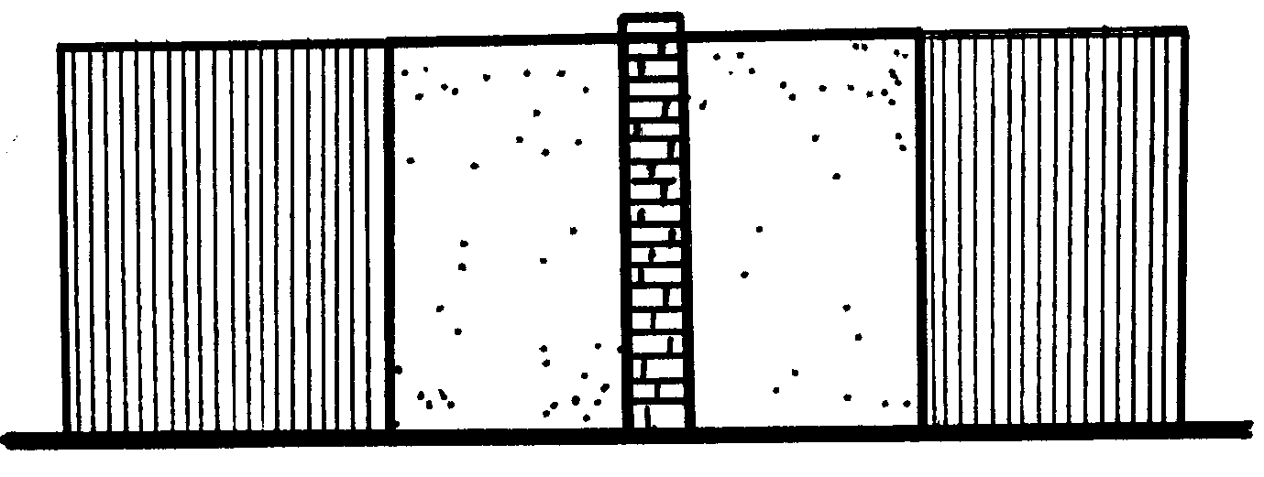
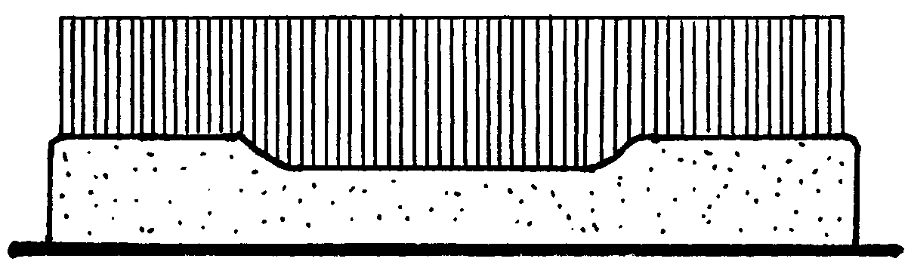
Solid wall and ornamental iron combination.
Solid wall and ornamental iron combination.

- Vegetative screening is encouraged, in lieu of walls or fencing, when a residential subdivision is adjacent to a neighborhood commercial development. Allowances for a solid wall may be made if the commercial use is required to have a wall or fence by national or state standards or if the residential area would be adjacent to the outdoor storage or loading area of an existing commercial use.

- A solid wall may be required when a residential subdivision is adjacent to an existing industrial development or land zoned for future industrial use.

- In the cases where a solid wall is used solely, or in combination with view-fencing, the solid portion shall be decoratively treated on all sides to match the residential product architectural style and design. Walls shall be off-set and/or undulating with decorative pillars every second lot. A low planter wall with landscaping may be built, on the public street side of the perimeter wall, in lieu of or in combination with the required decorative pillars.

- Wire mesh or chain link, no higher than the top rail, may be used when in conjunction with a pipe rail or corral style fencing but not as a stand alone fencing material. Pipe rail and corral style fencing shall not be higher than four (4) feet. The use of slat-filled chain link fences shall be prohibited.

  - Commercial and Industrial Standards:

    - When solid view-obscuring perimeter walls are necessary or required they shall be decoratively finished on all sides to match the commercial and/or industrial product architectural style and design.

    - Where a community commercial or industrial development share a common property line with a residentially zoned property (including lands in current agricultural production) or the community open space areas a solid perimeter wall shall not enclose the required landscaped buffer area. Rather the perimeter wall shall be a view-fence and any necessary view-obscuring screen walls shall be setback from the property line a minimum of twenty-five (25) feet or behind the landscaped buffer strip area whichever is greater.

    - Trash and refuse collection locations shall be screened with a six (6) foot decorative masonry wall. Trash and refuse areas shall be located such that they are not the visual focal point of a driveway or parking area, or cannot be viewed from a public street.

    - Outside storage areas, transformers, generators, heavy mechanical equipment and other similar eyesores shall be screened from the public street view and adjacent residential, office, and commercial uses to a height of at least six (6) feet. Materials shall not be stacked, piled, or stored in such a manner as to project above the screen wall.

    - Parking areas adjacent to the required front yard shall provide a decorative screen wall or landscape berm or combination thereof to a height not to exceed three (3) feet in order to adequately screen the undercarriages of the parked vehicles

Section 14-6-6 Access Requirements

- Rural, Estate, and Low Density Residential developments should front onto and take access from streets classified as arterial or collector streets as set forth in the Circulation Element of the General Plan.

- Medium Density Residential developments should be designed to provide lots that back or side onto streets classified as arterial or collector streets as set forth in the Circulation Element of the General Plan. A non-buildable tract, easement or additional right-of-way equal to the streetside side yard setback of the applicable zoning district, or fifteen (15) feet, whichever is greater, shall be platted between any street side or rear yard property line of any developable lot and the right-of-way of any arterial or collector street (see Figure 5).

- Every lot shall have frontage onto a fully-improved, publicly-dedicated and accepted street that meets all City of Maricopa street standards. Private streets that meet all City of Maricopa street standards may provide frontage to lots if the development is approved by the Planning and Zoning Commission and City Council for private streets.

- Every subdivision (residential, commercial and industrial) shall have at least two (2) separate and distinct access points both of which shall provide fully-improved and accepted access from public, or approved private streets, developed to City of Maricopa street standards. Additionally, every subdivision shall provide a multi-use trail/pathway from an access point other than those used to address the vehicular access requirements, where possible.

Figure No 5 – Access Requirements
for Arterial and Collector Roads
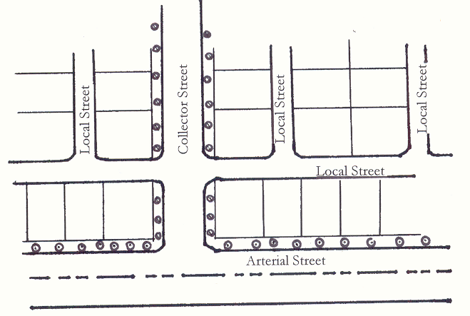

Section 14-6-7 Street Location and Arrangement

- The road system shall be designed to permit the safe, efficient, and orderly movement of traffic and pedestrians; meet the needs of present and future population served; have a simple and logical pattern; respect natural features and topography, and; present an attractive streetscape.

- In residential subdivisions, the road system shall be designed to serve the needs of the greater neighborhood. Through vehicular traffic should be discouraged by means of traffic calming methods, as defined by the Institute of Traffic Engineers (I.T.E.).

- There shall be no development of roadways built to Principal or Arterial standards unless and until that roadway and roadway alignment is shown within the latest Transportation Plan of the city. current City of Maricopa Small Area Transportation Study (SATS) as a proposed roadway. Street layout shall provide for the continuation of such streets as the SATS per the latest Transportation Plan of the city or as the City Engineer Zoning Administrator may designate.

- Adjacent to a railroad or limited access highway right-of-way the development of either open space or a street running parallel to the railroad or limited access highway shall be provided for the use of, and to act as a buffer to, the intervening residentially zoned property along with a protective barrier that must be approved by the City.

- Certain proposed streets, as designated by the City, shall be extended to the subdivision boundary to provide future connection with adjoining unsubdivided lands.

- Local streets shall be so arranged as to discourage their use by through traffic. Pedestrian needs shall be met.

- Where a proposed subdivision of Medium Density Residential development abuts or contains an existing or proposed Arterial or Collector right-of-way, a non-buildable landscaped tract equaling at least the depth of the minimum street side-yard setback of the base Zoning District, or fifteen (15) feet, whichever is greater, should be platted with non-vehicular access easements along the Arterial or Collector right-of-way. The exception to this would be for Rural, Estate, and Low Density Residential Developments where frontage onto Collector roadways may be desirable and/or encouraged.

- Streets shall be so arranged in relation to existing topography as to produce desirable lots of maximum utility, streets of reasonable gradient, and the facilitation of adequate drainage.

- Where private streets are approved, such streets shall be constructed to City public street standards and specifications and shall be placed into specific “street tracts” of land. Statements shall be contained on the plat and in both the Deed Restrictions and the Homeowners Association By-laws that those streets are declared private subject to an easement authorizing use by emergency and public service vehicles and utilities, and remain the permanent responsibility of the Homeowners Association. If at any time the streets are dedicated to, and accepted by the City, the streets must first be developed to the current standards specified by the City at the time of dedication.

- Alleys may be required in commercial and industrial subdivisions or may be desired in residential developments to facilitate detached rear loading garages. Where needed, and approved by City Council, they shall be a minimum of twenty-four (24) foot in width for commercial and industrial and a minimum of twenty (20) foot in width for residential.

Section 14-6-8 Street Design

- Design of Streets - The design of streets shall conform to standards established by this Ordinance. See Table 3, Table 4, Table 5, and Table 6 for specifics.

- Private Street - Private streets shall conform to above stated design standards unless otherwise approved by the City Council. Private streets shall be placed within their own parcel or tract of land. Where site conditions necessitate unique design solutions, modifications may be approved by the City Council.

- Cul-de-Sac Streets - Cul-de-sac streets shall be constructed with a minimum unobstructed turn-around area of forty-five (45) feet which shall be free from parked vehicles. The City Engineer may recommend an equally convenient form of turning and backing areas where extreme conditions justify. The maximum length of Cul-de-sac streets shall be 600 feet or 20 homes, as measured from the intersection of right-of-way lines to the extreme depth of the turning circle along the street centerline. An exception may be made where topography justifies but shall not be made merely because the tract has restrictive boundary dimensions, wherein provision should be made for extension of street pattern to the adjoining unplatted parcel and a temporary turnaround installed. Cul-de-sac streets shall be constructed with a minimum unobstructed turn-around area of fifty (50) feet, measured to back of curb. The minimum unobstructed area shall be kept free from parked vehicles. The City Engineer may recommend an equally convenient form of turning and backing areas where extreme conditions justify. The maximum length of Cul-de-sac streets shall be in accordance with the 2012 International Fire Code, Appendix D – Section D103.4. The City Engineer may grant an exception when the topography justifies but not merely because the tract has restrictive boundary dimensions, wherein provision should be made for extension of street pattern to the adjoining unplatted parcel and a temporary turnaround installed.

- Dead-end Streets - Dead-end streets will not be approved except in locations recommended by the Zoning Administrator as necessary to future development of adjacent lands; with an unobstructed temporary forty-five (45) foot turn-around.

- Private Access and Driveways - Access from private property to any dedicated street shall be constructed in accordance with permits issued by the City. Width of driveway at the property line shall be a minimum of twelve (12) feet and a maximum of forty (40) feet. The width will depend on the access to be served (i.e., residential or commercial) and shall be per the structural section designed by a Geotech Engineer. All residential access treatment within the right-of-way will be constructed with five (5”) inches of concrete or two (2”) inches of asphalt over five (5”) inches aggregate base.

- Bicycle Lanes – Bicycle lanes are designated on-street facilities that shall be provided on arterial and collector streets or as noted within Table 6 Figure 6-17 of this section. Within all new developments a bike lane no larger or smaller than shall be six and one-half (6’-5”) feet as measured from back of curb unless otherwise noted within this code or specifically approved by the City Engineer. Bicycle lanes shall be constructed on main collector roads throughout the development and arterial streets adjacent to the development. All bike lanes shall be marked with a white stripe no wider than five (5”) inches and clearly marked “bicycles only.” All bicycle lanes shall be delineated with a white stripe and clearly marked with word and symbol pavement markings per the current edition of the M.U.T.C.D.

- Street Intersections

- Streets intersecting a major street shall do so at a ninety (90°) degree angle; intersection of local streets shall not vary from ninety (90°) degrees by more than fifteen (15°) degrees. Exceptions to these requirements will be considered by the City Engineer based on terrain and other conditions.

- Street jogs Offset streets with centerline offsets less than 135 feet shall be prohibited except when approved by the City Engineer. Under special circumstances where local streets intersect collector or arterial streets, the City Engineer may require minimum centerline offsets of 400 feet.

- Local streets intersecting a collector street or arterial street shall have a tangent section of centerline at least 150 feet in length measured from the right of way line of the major street, except that no such tangent is required when local street curve has a centerline radius greater than 400 feet with the center located on the major street right-of-way line. Where topographic conditions make necessary other treatment to secure the best overall design, these standards may be varied by the City Council upon the recommendation of the City Engineer.

- Street intersections with more than four legs and y-type intersections where legs meet at acute angles shall be prohibited unless specifically approved by the City Engineer.

- At local intersections, property line corners shall be rounded by circular arc, having a minimum radius of twenty-five (25’) feet. Under special conditions, the City Engineer may recommend other dimensions for the above.

- A twenty-five (25’) foot by twenty-five (25’) foot sight triangle shall be provided at each corner of the intersection of two major streets. Heights of buildings, walls, landscaping, and other similar obstructions shall be restricted within the sight triangle. Under special conditions the City Engineer may recommend other dimensions for the above.

- Arterial and/or collector roadways that intersect with a multi-use trail shall be designed with a center median at the location of the trail intersection to provide protection to the trail users. The minimum dimensions of these center medians will depend upon the type of multi-use trail that the road bisects (see Figure 1 and Figure 2), as determined by the City Engineer.

- Street Grades - The minimum street grade shall not be less than two-tenths of one percent (0.2%). The maximum street grade shall not exceed a six (6%) percent grade. Street grades between six (6%) percent and ten (10%) percent may be approved only for such distances as topographical conditions make lesser grades impractical.

- Surface Treatment

  - The traveled way of all arterial and collector streets shall be surfaced with asphalt concrete.

  - The placing of asphalt concrete shall be accomplished under generally accepted construction techniques provided in Section 321 of the MAG Standard.

  - The use of rubberized asphalt may be required at the discretion of the City Engineer for certain arterial and collector streets.

  - Unless otherwise specified in the special provisions, emulsified asphalt shall be a grade SS-1h, CSS-1h, or CQSH, as specified in M.A.G. Section 713. The emulsified asphalt shall be diluted in proportions of 50% water and 50% emulsified asphalt, the diluted material shall be well mixed before application. Immediately before applying the emulsion, the area to be surfaced shall be cleaned of dirt and loose material by means of power brooms, or pick-up brooms supplemented by hand brooms if necessary.

  - It shall be applied by a distributor truck equipped with fog nozzles at the approximate rate of 0.10 gallon per square yard. The exact rate shall be as directed by the Engineer. The distributor truck shall be as specified in M.A.G. Section 330.

  - The fog seal shall not be applied until an inspection of the surfaces has been made by the Engineer and he has determined that the surfaces are suitable. Fog seal shall be applied to the road surface six (6) months to one (1) year after asphalt placement.

- Structural Section - The thickness of base and surface treatment for all streets shall be based on the geotechnical/soil report and pavement thickness provided by the developer. In no case will base be less than six (6”) inches and the surface treatment be less than two (2”) inches (compacted thickness).

- Aggregate Base Course (ABC) - All developments will be required to submit a geotechnical/soils report and pavement recommendation prepared by an Arizona Registered Geotechnical Engineer. The pavement report will recommend at least two alternative structural sections for each street classification. With approval of the City Engineer, additional asphalt may be substituted for untreated base at the ratio of one (1”) inch to three (3”) inches. The top four (4”) inches must be ABC,. The City Engineer may approve select material for the balance may be ABC or select material.

- Rights-of-Way (ROW) - Provide street right-of-way widths that are in accordance with the latest Transportation Plan of the city Maricopa Small Area Transportation Study (SATS) and the Maricopa Transit Feasibility and Implementation Study (TFIS), if addressed by either of those studies, but not less than the following:

Table 3 ROW Width’s
Roadway Classification | ROW Width | Refer to Figure for additional Design Details
Parkway | 200’ | No. 6
Principal Arterial I | 150’ | No. 7
Principal Arterial II | 150’ | No. 8
Minor Arterial | 110’ | No. 9
Collector | 80’ | No. 10
Village Collector  (option 1) | 95’ | No. 11
Village Collector  (option 2) | 115’ | No. 12
Character Area | 60’ | No. 13
Local (option 1) | 60’ | No. 14
Local (option 2) | 50’ | No. 15
Local (option 3) | 50’ | No. 16
Industrial/Commercial Local | 70’ | No. 17

Table 3 – Right-of-Way Dimensions
Street Classifications | Right-of-Way Width (minimum)
Parkway | 200 feet
Village Collector | 93 and 123 feet
Arterial Roadway | 110 & 140 feet
Collector Roadway | 80 feet
Local Street – Residential (Rural & Estate) | 50 feet
Local Street – Residential (Low & Medium Density) | 50 & 60 feet
Local Street – Residential (High Density) | 60 feet
Local Street - Commercial | 60 feet
Local Street – Industrial | 70 feet

Table 4 – Minimum Street Structural Section
Street  Classifications | Untreated Base (minimum) | Asphalt Base  Course | Asphalt Surface Course
Arterial Roadway | 10” | 3” - A 1½ | 2” - C ¾
Collector Roadway | 10” | 3” - A 1½ | 2” - C ¾
Local Street – Residential  (Rural & Estate) | 7” | 2” – C ¾ | 1” – D ½
Local Street - Residential  (Low & Medium Density) | 6” | 2” - C ¾ | 2” - D ½
Local Street - Residential  (High Density) | 6” | 2” - C ¾ | 2” - D ½
Local Street  Commercial & Industrial | 8” | 2” - C ¾ | 2” - D ½

Table 5 – Minimum Road Design Standards
Street Type/Category | Arterial | Collector | Local Residential  Rural & Estate | Local Residential  Low - High Density | Local Commercial & Industrial
Design Speed | 55 | 35 | 30 | 30 | 30
Min. Radius of Horizontal  Curves w/o Superelevations (ft) | 1800 | 500 | 200 | 200 | 200
Min. Length of Tangent between Reverse Curves (ft) | 300 | 100 | 100 | 100 | 100
Min. Length of Tangent between Curves - Same Direction (ft) | 550 | 100 | 100 | 100 | 100
Min. Vertical Curve (ft) | 500 | 100 | 100 | 100 | 100
Passing Sight Distance (ft)  (per ASHTO) | 1950 | ⁽¹⁾ | ⁽¹⁾ | ⁽¹⁾ | ⁽¹⁾
Right Angle Intersection Sight Distance (ft) (per ASHTO) | 860 | ⁽¹⁾ | ⁽¹⁾ | ⁽¹⁾ | ⁽¹⁾
Min. Tangent Length  Approaching Intersections (ft) | 300 | 200 | 150 | 150 | 150

(1) Consult with the City Engineer for the specific standard to be used.

Table 6 Street Cross Section Design
Roadway Classification | R/W Width (feet) | Pavement Width ⁽¹⁾ | Curb Type | # Drive Lanes ⁽²⁾ | Sidewalk or Multi-use Trail  & Location | On-Street Parking | Landscape Strip | Esmt Required
Principal Arterial 1  Principal Arterial 2 | 140 | 102 | Vertical | 3 + turn + bike lane | S/W @ 5’ b.o.c. each side | None ⁽⁸⁾ | 8 | None
Minor Arterial | 110 | 74 | Vertical | 2 + turn + bike lane | S/W @ 5’ b.o.c. each side | None ⁽⁸⁾ | 7 | None
Collector Street | 80 | 50 | Vertical | 1 + turn + bike lane | S/W @ 5’ b.o.c. each side | None ⁽⁸⁾ | 5 | None
Local Street Res.  Rural & Estate | 50 | 24 | Ribbon | 1 | Trail @ 5’ b.o.c.  1-side | None ⁽⁸⁾ | 8 & 15 | None
Local Street Res.  Low Density | 50 | 24 | Roll | 1 | S/W @ 5’ b.o.c.  1-side | None ⁽⁸⁾ | 13 | None
Local Street Res.  Medium Density | 50 | 24 | Roll | 1 | S/W @ b.o.c.⁽⁷⁾  2-side | None ⁽⁸⁾ | 13 & 8 | 8’ PUE  both sides
Local Street Res.  Medium Density | 50 | 28 | Roll | 1 | S/W @ b.o.c. ⁽⁷⁾  2-side | 1-side ⁽⁸⁾ | 6 & 6 | 8’ PUE  both sides
Local Street Res.  Medium Density | 60 | 32 | Roll | 1 | S/W @ b.o.c. ⁽⁷⁾  2-side | 2-side | 9 & 9 | 8’ PUE  both sides
Local Street Res.  Medium Density | 60 | 36 | Roll | 1 | S/W @ b.o.c. ⁽⁷⁾  2-side | 2-side | 7 & 7 | 8’ PUE  both sides
Local Street Res.  High Density | 60 | 36 | Vertical | 1 | S/W @ b.o.c.⁽⁷⁾  2-side | 2-side | 11 & 6 | 8’ PUE  both sides
Local Street  Mixed Use | 60 | 36 | Vertical | 1 | S/W @ b.o.c.⁽⁷⁾  2-side | 2-sides | 12 & 7 | 8’ PUE  both sides
Local Street  Commercial. | 60 | 36 | Vertical | 1 + turn | S/W @ b.o.c.⁽⁷⁾  2-side | 2-sides | 7 & 7 | 8’ PUE  both sides
Local Street  Industrial | 70 | 40 | Vertical | 1 + turn | S/W @ b.o.c.⁽⁷⁾  2-side | 2-sides | 5 & 5 | 8’ PUE  both sides

- Pavement width shall be measured from edge of pavement (not including curb & gutter).
- Number of drive lanes is for each direction. All drive lanes shall be a minimum of twelve (12) feet in width or wider if required by the City Engineer or the SATS Report..
- Sewer utilities shall be located under the pavement or within a sewer easement.
- Dry utilities shall be located within the P.U.E.
- Sidewalks (S/W) shall be constructed of portland cement concrete. be a minimum of 5’ 0” in width along Local Streets and 6’-0” along Arterial and Collector Streets.
- Multi-use Trails shall be 13’-0” in width (9’ hard surface and 4’ decomposed granite).
- The City strongly encourages curb separated sidewalks (see Sec.14-6-4 B. 8);open space incentive.
- “No Parking” signs shall be installed by the developer per the location and spacing requirements of the City.

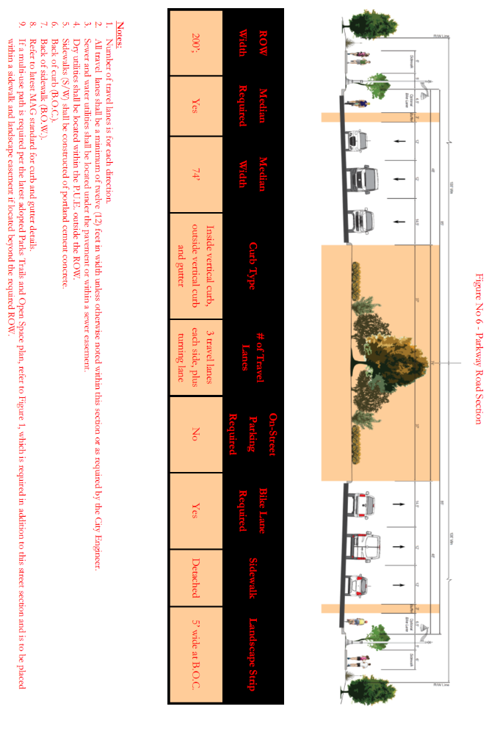

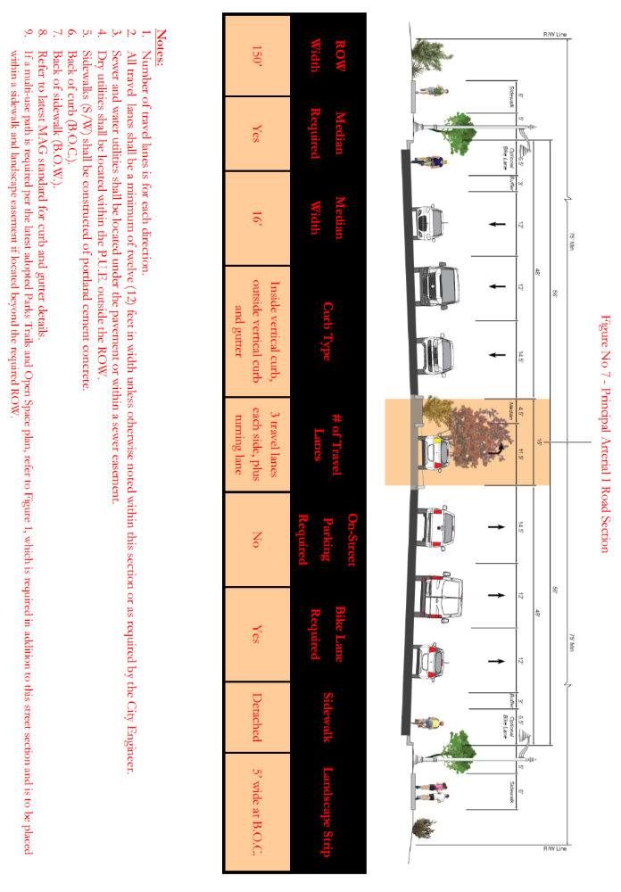

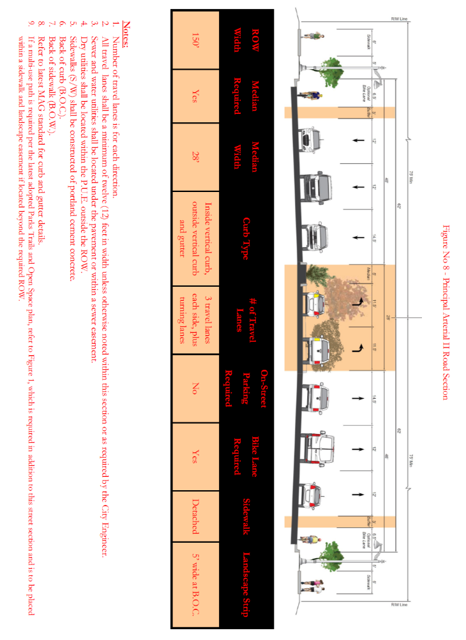

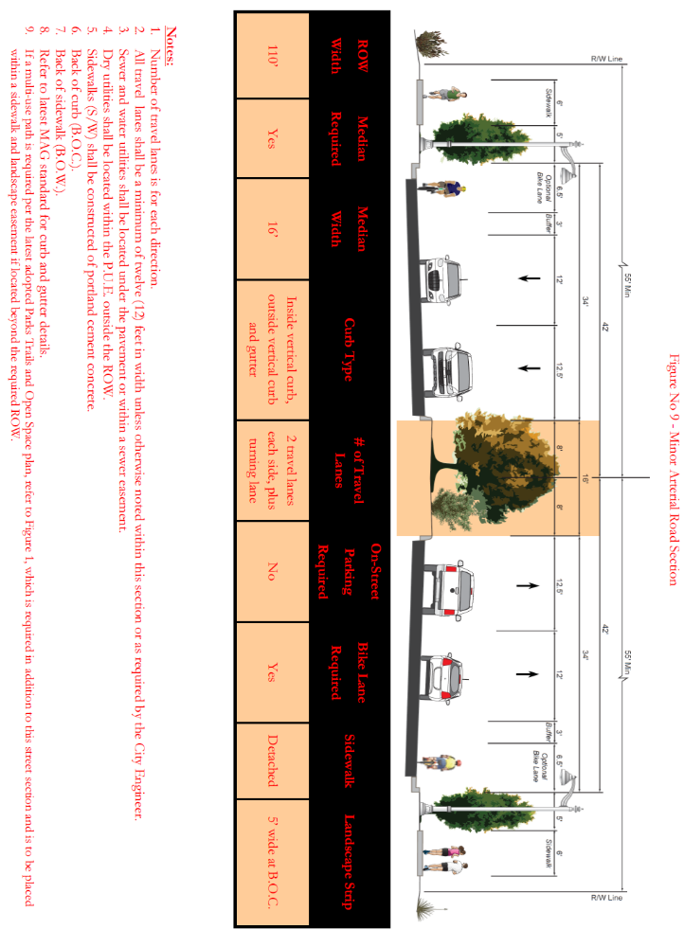

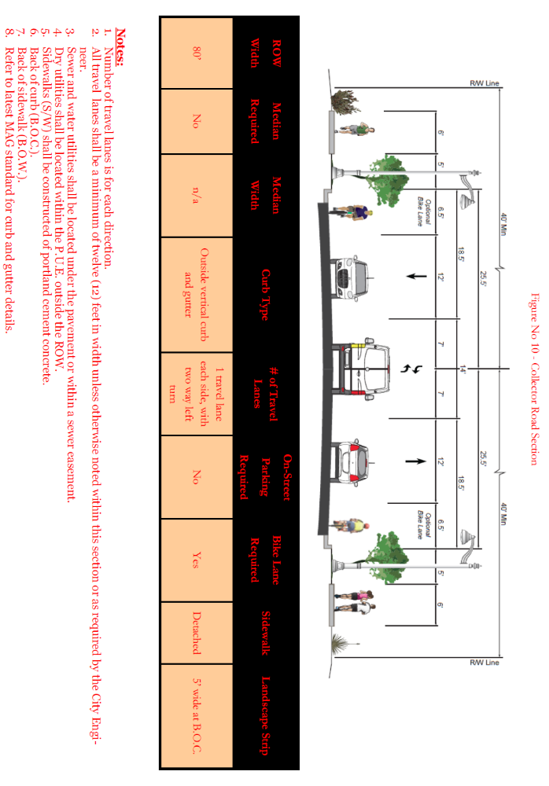
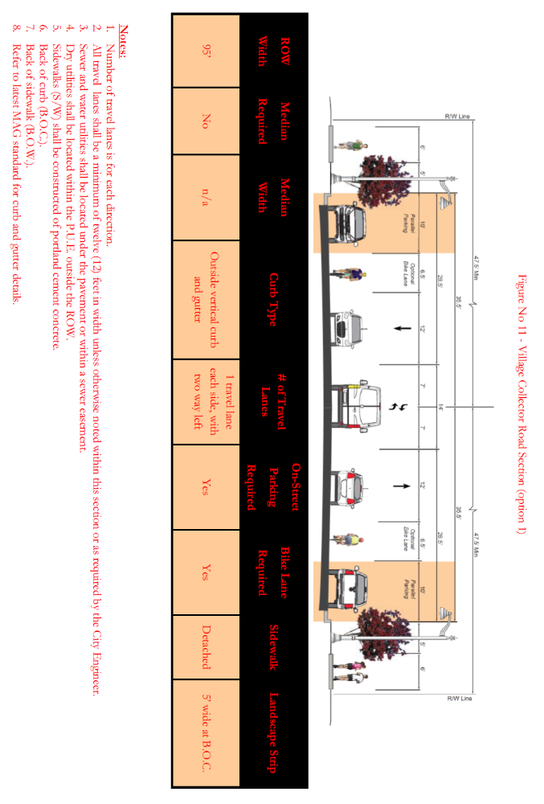
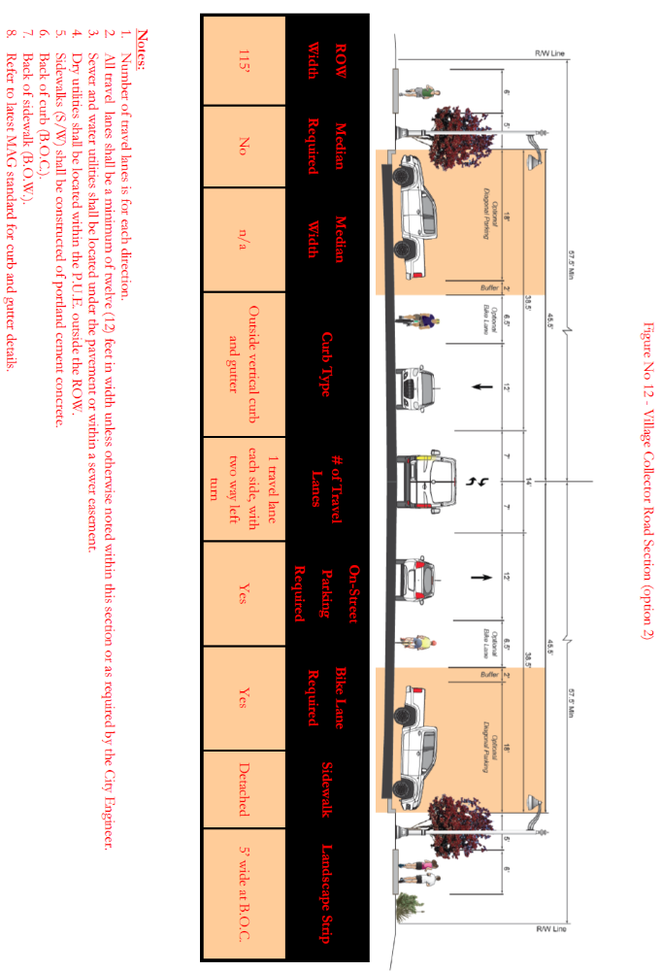

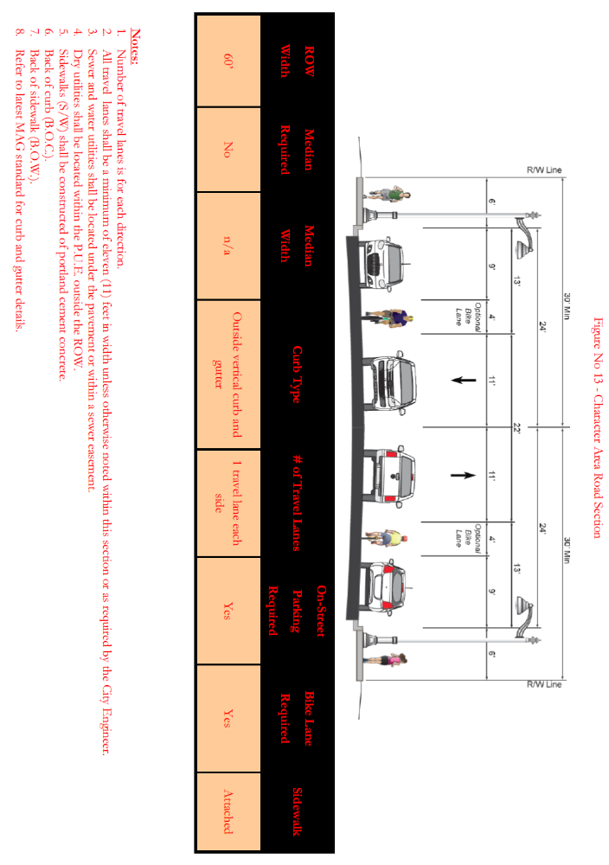

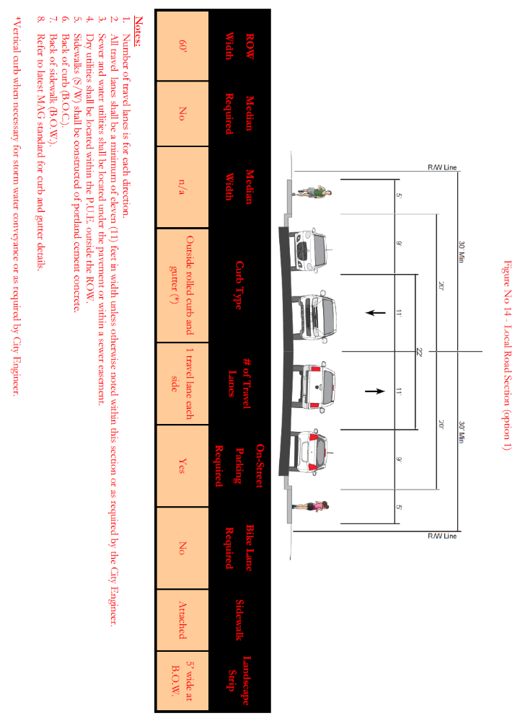

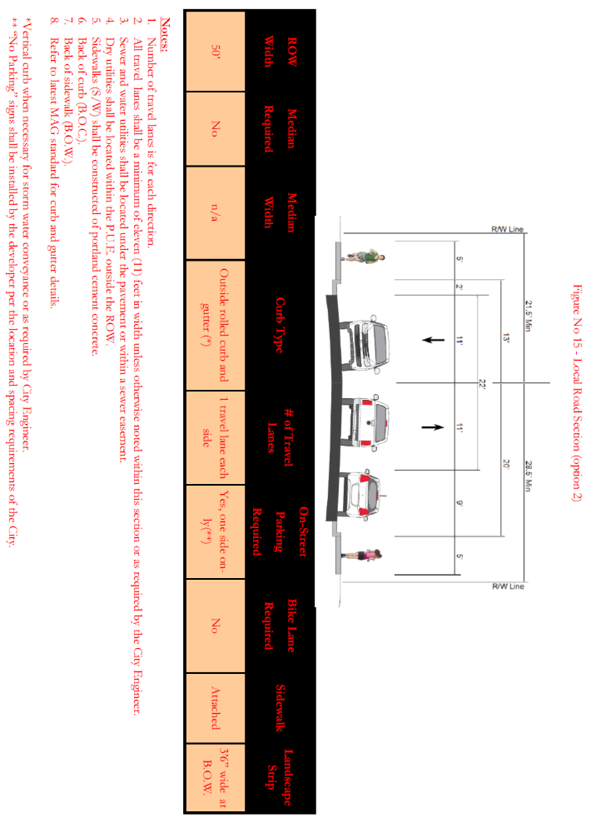

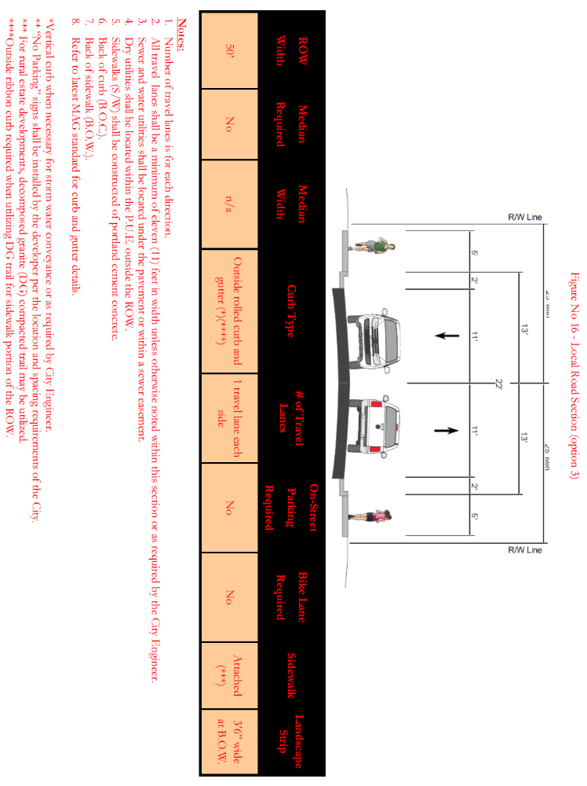

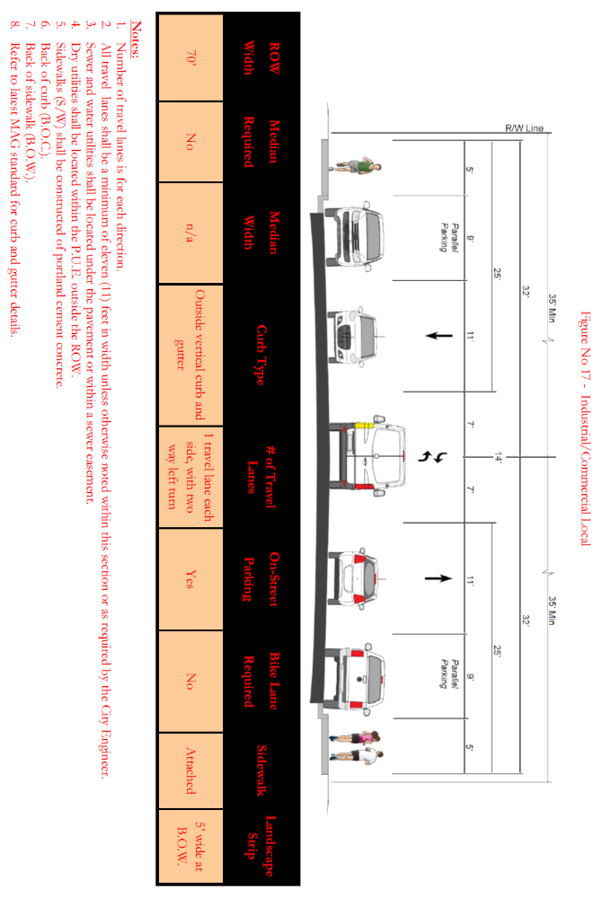

Section 14-6-9 Lot Planning

- Single-family residential lots shall not have a width-to-depth ratio greater than one to three. Special lot designs that do not meet this requirement may be permitted through the P.A.D. or M.P.D. process on a case-by-case basis.

- All proposed lots must be developable without the need of a variance, waiver or further discretionary approvals from the City. Prior to final plat approval the City may require additional documentation, including but not limited to engineered concept plans, for lots with questionable development ability.

- Corner lots shall generally be designed larger to accommodate the increased setback requirements of the Zoning Ordinance.

- Side lot lines shall be substantially at right angles or radial to street lines, except where other treatment may be justified in the opinion of the Zoning Administrator.

- Residential lots extending through the block and having frontage on two parallel streets which are both local streets or one of which is a local street and the other is a collector street shall not be permitted; except when there are Commercial or Industrial Zoning Districts on the opposite side of the street and except where justified in the opinion of the Zoning Administrator.

Section 14-6-10 Easement Planning

- Eight-foot Easements will be required for all public and/or private utilities outside of the street right-of-way and shall be placed along lot lines on all street sections as required by the City Engineer Public Utility Easements shall be dedicated to the City for the purpose of permitting and licensing the installation, relocation, and maintenance of private utilities. All public utilities shall be placed within Public Utility Easements, unless otherwise permitted by the City Engineer. utility companies. For information on the requirements contact the specific utility companies serving the development.

- Where a river, wash or important surface drainage course abuts or crosses a development, dedication of a drainage easement of a width sufficient to permit widening, deepening, relocating, or protecting and maintaining said water course shall be required. Drainage easement width shall be approved by the City Engineer based upon the hydrological analysis of a 100-year frequency storm.

- All retention areas shall be in tracts with drainage easements.

Section 14-6-11 Street Naming

- Street names shall comply with the City of Maricopa Street Naming and Addressing Procedures (SNAP). overall City of Maricopa street naming system.

- Street names should be consistent with the natural alignment and extension of existing named streets.

- The developer shall propose the street names at the preliminary plat submittal stage and the names shall be recommended by the Commission and approved by Council.

- Reflectorized street name signs using current “Manual on Uniform Traffic Control Devices” (M.U.T.C.D.) letter size and numbers shall be placed at all street intersections and be in place by the time the street pavement is ready for use. Specifications for design, construction, location, and installation shall conform to M.U.T.C.D. standards.

Section 14-6-12 Drainage

- Proper and adequate provisions shall be made for disposal of storm water; this shall apply equally to grading of private properties and to public streets. Existing major water courses shall be maintained as drainage ways. Drainage shall meet the requirements of the “Drainage Policy” of the City of Maricopa. Streets may be used for drainage conveyance only.

- Post development flows cannot exceed pre-development flows in peak runoff, volume, or velocity and may not concentrate sheet flows without down stream off-site control.

- Drywells are discouraged. If drywells are necessary they shall be spaced as far apart as possible and only fifty (50%) percent of the percolation capacity can be used in calculating the required number of drywells to be utilized. In addition a maintenance plan shall be prepared that provides for routine inspection and maintenance to the approval of the City Engineer.

Section 14-6-13 Sanitary Sewage Disposal

- All subdivisions within the City of Maricopa shall install sewer collection lines, and all dwelling units shall be required to connect to the sanitary sewer collection system. If there is no sewer main available, then the developer must apply to the Sanitary Sewer Provider for sewer extension information. If sewer service is not available and the Sanitary Sewer Provider issues a written waiver approving the use of an alternative sewage disposal system, an alternative sewage disposal system may be approved by the City.

- All subdivisions not in the Sanitary Sewer Provider service area shall submit a sewer service plan acceptable to Pinal County Health Department, Arizona Department of Environmental Quality (A.D.E.Q.), and the Sanitary Sewer Provider for possible annexation into the district’s service area.

- Septic tanks shall be approved by Pinal County Health Department.

- Sewer lines shall be reviewed by the City Engineer and approved by the Sanitary Sewer Provider, A.D.E.Q., and by Pinal County Health Department.

- Service stubs for underground utilities to platted lots within the subdivision for underground utilities shall be placed to the right-of-way line or the back line of the public utility easement whichever is greater.

- Sanitary sewer lines shall be extended to the boundaries of the plat to provide service connections to abutting unsubdivided land.

- If a separate sanitary sewer easement is needed it shall be fifteen feet (15’) in width.

- The developer will need to refer to the Sanitary Sewer Provider “Design Criteria & Specifications” design criteria & specifications for more specific design regulations.

Section 14-6-14 Water System

- Each lot or building unit shall be supplied with potable water in sufficient volume and pressure for domestic use and fire protection purposes. Design and construction of any and all facilities relating to the supply, storage, transmission, treatment and distribution of potable water within or outside of any subdivision must meet with the written approval of the water provider and Maricopa Fire District/Department.

- All design and construction must meet all applicable City and A.D.E.Q. specifications and requirements in force at the time of plan review and approval. If it is necessary for the City to apply specifications or requirements not in force at the time of plan review, but necessary to achieve the orderly and proper development of any portion of the water system, the City reserves the right to enforce such specifications and requirements to insure and protect the public welfare.

- The developer of a subdivision may be required by the City of Maricopa and/or the water provider to supply to the water system an amount of new water supply and/or storage facilities to offset the demand on the existing or planned water system imposed by owners of property or building units within the subdivision.

- The City assumes no liability for providing water to any proposed or actual subdivision. All water supply within the City is provided by water companies or districts.

- Water specifications and requirements relating to fire protection are established by the currently adopted fire code of the State of Arizona. At a minimum fire protection must be provided in accordance with city’s latest adopted Fire Department code the 1997 Uniform Fire Code, or updated versions of said code, as adopted by the State of Arizona and/or the City of Maricopa.

- Line Sizing: Minimum size lines for water lines shall be six (6”) inches. Minimum eight (8”) inch lines shall be required on dead-end hydrant lines longer than three hundred (300’) feet.

- Valves: There shall be a minimum of three (3) valves at crosses, two (2) valves at tees and one (1) valve at each fire hydrant tee. Shutdown valving shall be arranged such that no more then than four (4) valves are required to make a shutdown in any section of waterline. No more than thirty (30) homes or two (2) fire hydrants shall be out of service during a water line shutdown.

- Services:

1. Minimum service tap, service pipe and meter shall be three-quarter (3/4”) inches and shall serve only one (1) property. A minimum one (1”) inch service tap, pipe and meter, servicing only one (1) property, shall be required on all long cul-de-sac runs, fire sprinkled residences, all Rural and Estate residential developments, and all commercial and industrial developments.

2. Service stubs for underground utilities to platted lots within the subdivision for underground utilities shall be placed to the right-of-way line or the back line of the public utility easement, whichever is greater.

- Fire Hydrants: Maximum spacing between fire hydrants shall be five hundred (500’) feet in single family residential areas and two hundred (200’) feet in all other areas. Refer to the city’s latest adopted Fire Department code for fire hydrant location requirements.

- Water distribution lines shall be extended to the boundaries of the plat to provide service connections to abutting unsubdivided land.

- The above regulations shall be the minimum standards regardless of the individual water provider’s standards. The developer will need to refer to the specific “Design Criteria & Specifications” design criteria & specifications established by the individual water provider; the more restrictive regulation shall apply.

Section 14-6-15 Outdoor Lighting

- Where required and/or permitted all outdoor light fixtures shall be fully shielded (full cut-off) and shall meet the State of Arizona Light Pollution Ordinance contained in the Arizona Revised Statutes (A.R.S.) §49-1101 et seq. The term “fully shielded” means the fixture shall be shielded so that light rays emitted by the fixture, either directly from the lamp or indirectly from the fixture, are projected below a horizontal plane running through the lowest point on the fixture where light is emitted. Further, the light sources must be shielded in a manner that the bulb or light source from the fixture is not visible from an adjoining property or from the street view.

- Outdoor light fixtures, lamps and other devices, permanent or portable, used for illumination or advertisement for: recreational areas, walkways within open space areas, parking lot lighting, and street lighting shall comply with these provisions and the City of Maricopa Zoning Ordinance.

- Street lights shall be installed along arterial streets, collector streets, at the subdivision entrance from the arterial or collector street, and at those street light locations as required by the City Engineer for safety (i.e. railroad and at-grade wash crossings).

- Where required along State Highways the installation height shall be limited to American Association of State Highway and Transportation Officials (A.A.S.H.T.O.) standards. In all other areas and along other roadways the installation height shall be limited to the following:

  - Street lights along arterial roads shall be limited to an installation height of twenty-five (25’) feet.
  - Street lights along collector roads shall be limited to an installation height of twenty (20’) feet.
  - Parking lot lights (recreational, commercial, and industrial) shall be limited to an installation height of sixteen (16’) feet within the interior of the parking lot and twelve (12’) feet along the perimeter of the parking lot.
  - Parking areas within multi-residence developments (condominiums, apartments, etc.) shall be limited to an installation height of twelve (12’) feet for freestanding fixtures. Motion sensor/detector light fixtures are encouraged to be mounted under and recessed into the parking shade canopy/structures.
  - Walkway path lighting (recreational and within multi-residence developments) shall be limited to an installation height of ten (10’) feet for freestanding fixtures with the preferred fixture being a low level bollard style fixture.

- Street Light Design shall be per The AASHTO Roadway Lighting Design Guide, October 2005 with the following exceptions:
  - The location of street light bases shall be one (1) foot back of attached sidewalk or 2.5 feet behind the curb in case of meandering sidewalk or no sidewalk.
  - On local streets, street lights shall be located at end of blocks, mid-blocks, and intersections.
  - Street lights shall be spaced at 300’ on collector streets.
  - Street lights shall be spaced at 300’ on both sides of the ROW and staggered at 150’ for Arterial Streets.
  - Fixture shall be designed to be fully shielded to meet Dark Sky standards. “Fully shielded” shall mean that those fixtures shall be shielded in such a manner that light rays emitted by the fixture, either directly from the lamp or indirectly from the fixture, are projected below a horizontal plane running through the lowest point on the fixture where light is emitted.
- If the developer, property owners, or Homeowners Association desire street lights for the local streets within and throughout the subdivision the cost for installation, maintenance, and monthly operational/utility bills for these street lights shall be the sole responsibility of the developer, property owners, or H.O.A. Street lights along the local streets throughout a subdivision shall be limited to a height of fifteen (15’) feet, and should be limited to intersection locations. Individual residential photo-cell operated house lighting may be provided as an option and is the sole responsibility of the property owners and controlled by the local H.O.A.

- Parking lot lighting within a commercial subdivision/development shall be limited to a maximum lighting intensity (eye illumination levels) of 2.0 Lux or 0.20 footcandles, as measured at the property line. However, if the commercial development abuts or is adjacent to (across the street from) a residential zoning district the maximum lighting intensity (eye illumination levels) in the parking area shall be 1.0 Lux or 0.10 footcandles measured at the property line. Within an industrial subdivision/development the maximum lighting intensity (eye illumination levels) in the parking area shall be 1.0 lux (0.10 fc) measured at the property line.

Section 14-6-16 Public Utilities

- All electric lines, except those of greater than twelve thousand five hundred (12,500) KVA volt capacity, and all telephone lines, cable television lines, and other communication and utility lines necessary to serve the subdivision shall be installed underground. The developer of the property shall be responsible for the costs of the underground construction in accordance with the underground policy of the serving utility.

- When as a result of the subdivision development, it is necessary to relocate, renew or expand existing facilities within or adjacent to the platted area, the developer shall make the necessary arrangements with the serving utility for these installations to be placed underground at the time of development of the property as part of the required off-site and on-site improvements.

- The developer shall arrange with the serving utility for, and be responsible for, the cost of underground service lines to approved street light locations.

- Service stubs for underground utilities to platted lots within the subdivision for underground utilities shall be placed to the right-of-way line or the back line of the public utility easement whichever is greater.

- Underground utilities shall be extended to the boundaries of the plat to provide service connections to abutting unsubdivided land.

- The above regulations shall be the minimum standards regardless of the utility company’s standards. The developer will need to refer to the specific “Design Criteria & Specifications” design criteria & specifications established by the utility companies; the more restrictive regulation shall apply.

- The subdivider shall be responsible for compliance with the requirements of this section and shall make the necessary arrangements with each of the public utility companies involved for the installation of underground facilities. Letters from each of the public utility companies indicating that the arrangements have been made shall be submitted to the city at the time the final subdivision plat is filed.

